# Version:2.0

# PPDM Module Specification

## Admin module Features

1. There should be a Sign In option

1. The Sign In should open a login form as below

1. If logged in user is an Administrator, the Module should become accessible for adding data in backend database



1. On Clicking the <Module Name>, Menu would open.

1. On Clicking the **Websites** menu option, the following entry form should open to add records

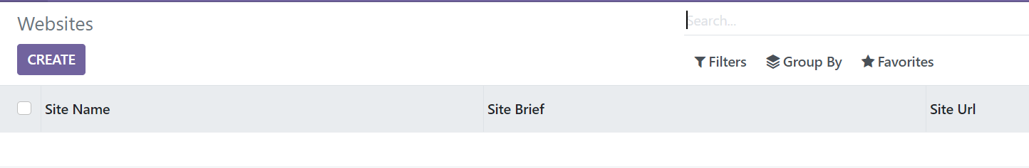

1. On Clicking **Create** following Entry Form should Open for entering data

1. After Entering Site Name, Site Brief, Site Url, the user can add Cookie Categories. To do this user will click **Add a line**. This will open below screen

1. After the data is saved the saved data will appear as below
2. On Clicking the **Vendors Sites** menu option, the following entry form should open to add records

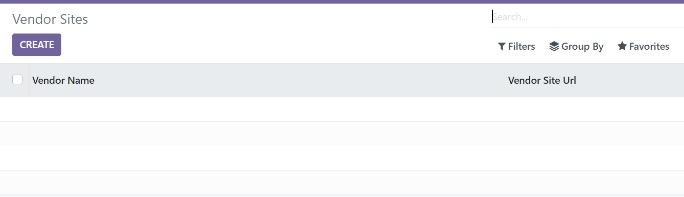

1. On Clicking **Create** following Entry Form should Open for entering data

1. After Entering Vendor Name, Vendor Site Brief, Vendor Site Url, the user can add Cookie Data. To do this user will click **Add a line**. This will open below screen

1. After the data is saved the saved data will appear as below

## Web page Features

1. Website should be accessible using URL: [http://localhost:8069/<modulename>/website](http://localhost:8039/%3cmodulename%3e/website)



1. On the home page there should be a Search feature:



1. Site details should come when a search string matches Site Name



1. On Clicking any of the listed item, its Cookie Category details should come



--- End of Document ---